**EXCLUDE - Level of Details (LOD’s) Expressions in Tableau**

**EXCLUDE:** “EXCLUDE” level of detail expression is used to omit specified dimensions from the aggregations. Using “EXCLUDE”, user can omit the lower level granularity dimension which is present in the view and can directly calculate the value at higher granularity level.

“EXCLUDE” level of detail expression is majorly used to calculate ‘difference from overall average’ or ‘percent of total’

**Example:**

Requirement: Let’s consider the requirement is to compare total sales with the monthly sales of East region.

Data: Consider the data with required “Order Date”, “Region” and “Sales” fields.

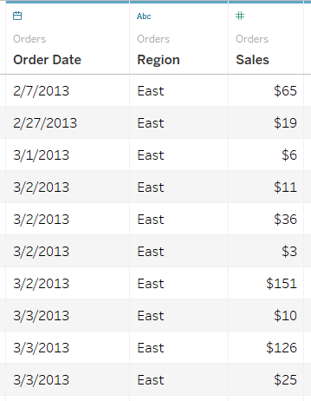

Current view: To get the monthly sales we need to have “Region”, “Month” and “Sum of Sales” in the view. Therefore, in the current view if we directly use “SUM(Sales)” across “Months” then it will show the total value of sales taking into consideration all the respective region 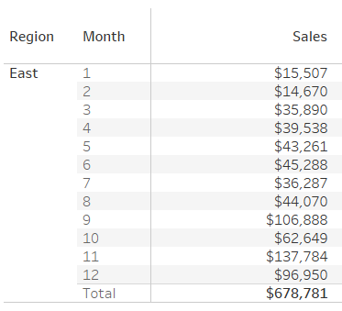

But, as the requirement is to compare the monthly sales with total sales, we need to create a certain calculation which can return the total sales across all the 12 months. In other words, we need to exclude “Month” in the calculation so that we can have total sales value for region.

Formula/Expression: *SUM({EXCLUDE [Month] : SUM([Sales])})*

Explanation:

1. In the above formula, we are excluding the lower level of dimension i.e. Month to get the aggregate (sum) values of Sales at higher level i.e. Region. This exclude calculation returns the same total sales value across all rows

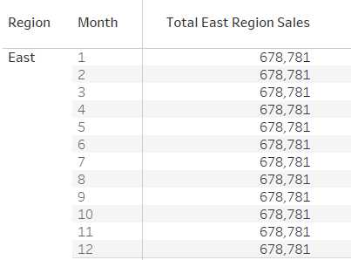

1. Now, to compare the sales across each other we can divide “SUM(Sales)” by “Total East Region Sales” (which is calculated using Exclude function)

Tableau View:

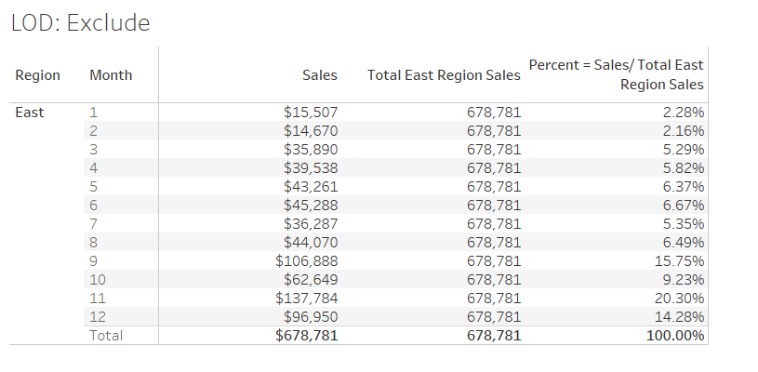

1. The major advantage of using this method is that it makes analysis of data very easy. For example, by looking the above result user can infer that the highest sales happened across month of November i.e. ~20%